**WEEK 5**

**CREATING MICROSERVICES FOR ACCOUNT**

***STEP1:***

From <https://start.spring.io> , I filled all the fields and added the necessary dependencies and extracted the zip file

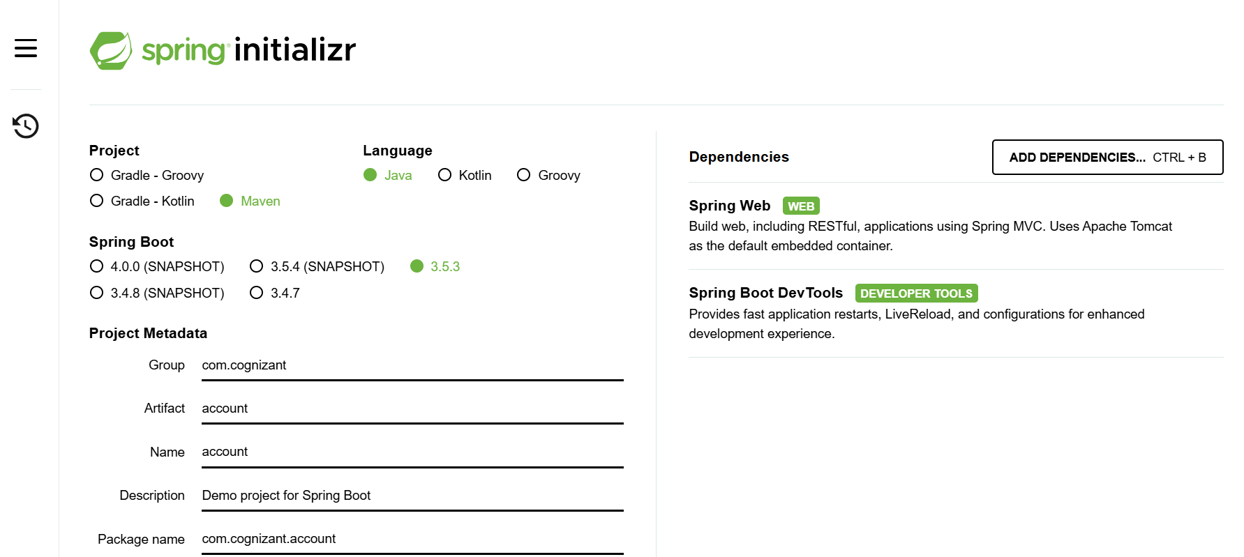

***STEP 2:***

I created a package called Controller under the account package. Under the controller package, I created an AccountController java class

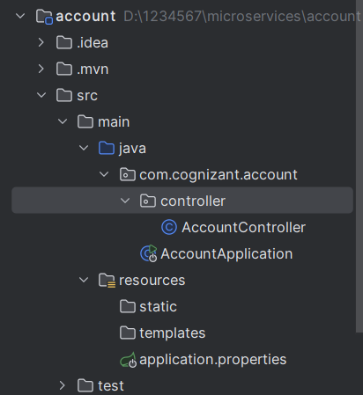

***STEP 3:***

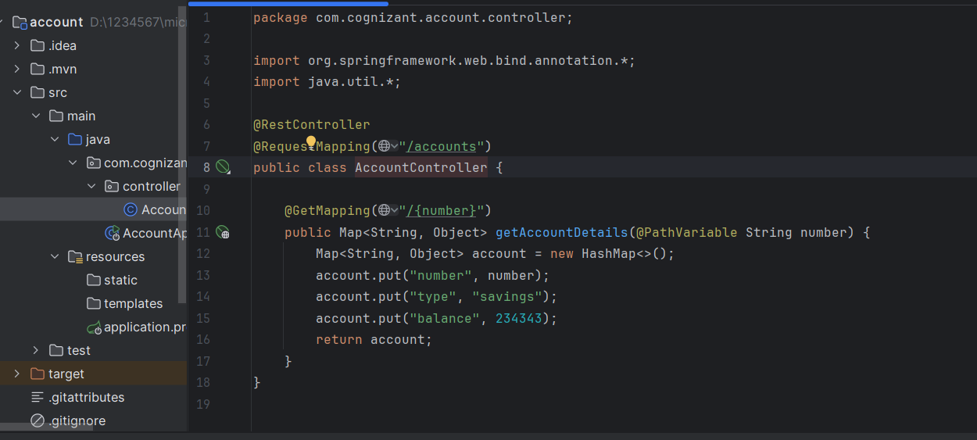

***STEP 4:***

After running the program , Open POSTMAN APPLICATION

**GET METHOD:** <http://localhost:8080/accounts/0098787973432>

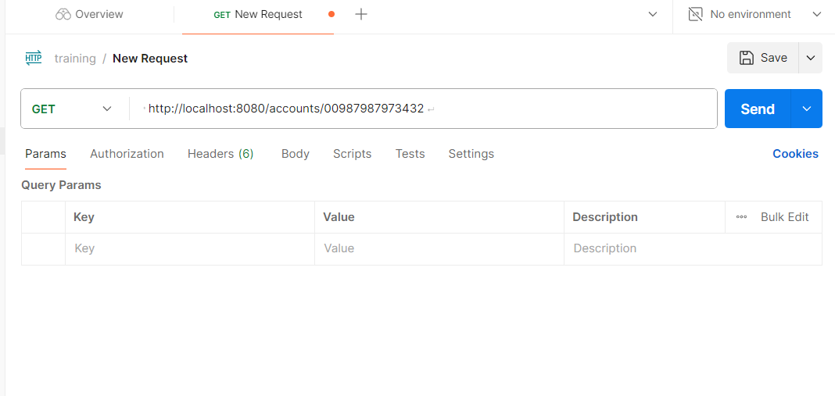

***STEP 5:***

***OUTPUT,***

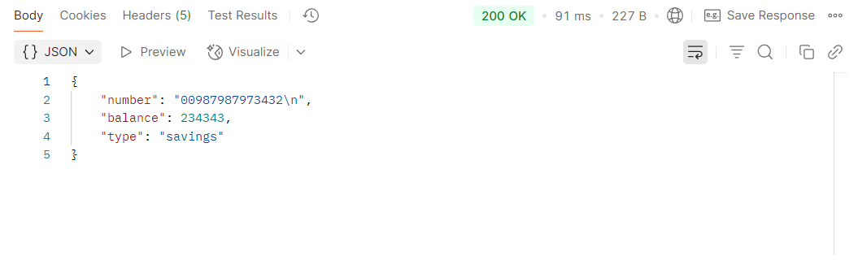

***___________________________________________________________________________________***

**CREATING MICROSERVICES FOR LOAN**

***STEP1:***

From <https://start.spring.io> , I filled all the fields and added the necessary dependencies and extracted the zip file

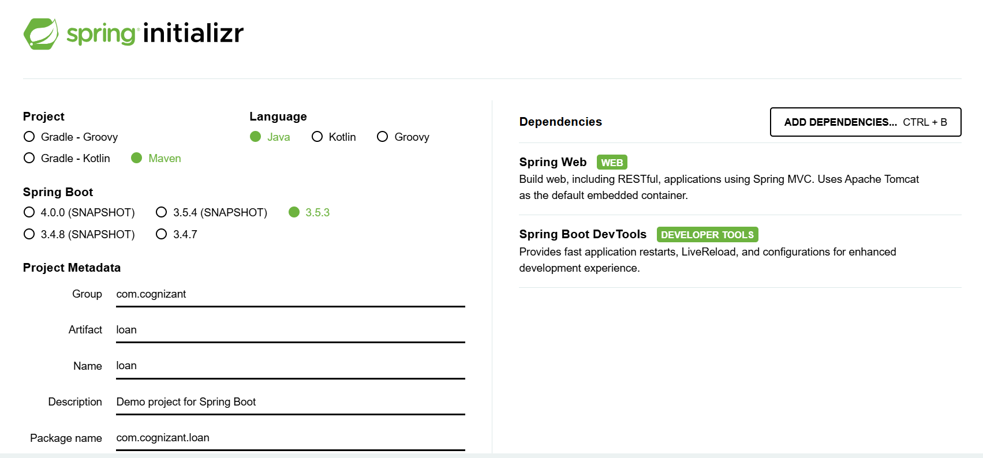

***STEP 2:***

I created a package called Controller under the loan package. Under the controller package, I created an LoanController java class

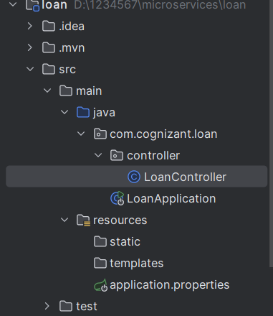

***STEP 3: LoanController***

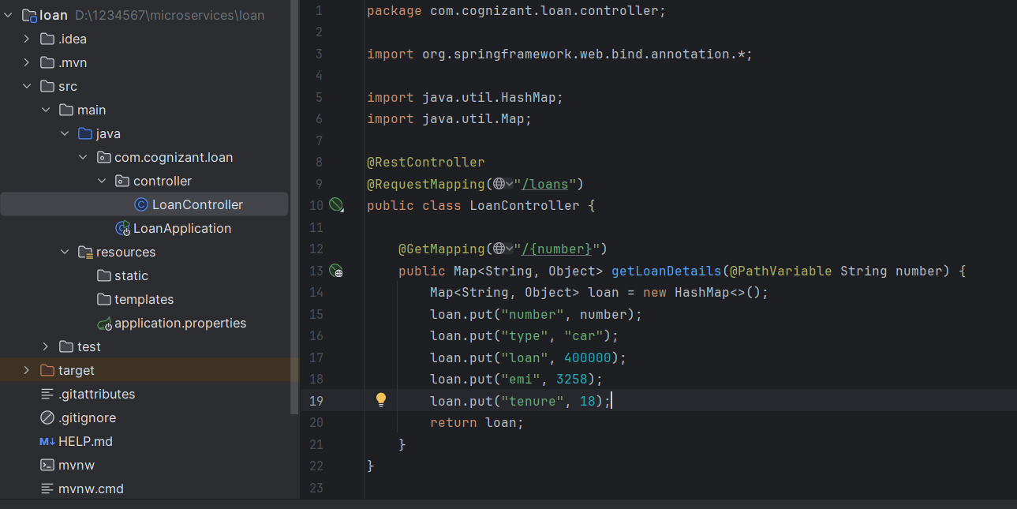

***STEP 4:***

After running the program , Open POSTMAN APPLICATION

**GET METHOD:** <http://localhost:8081/loans/H00987987972342>

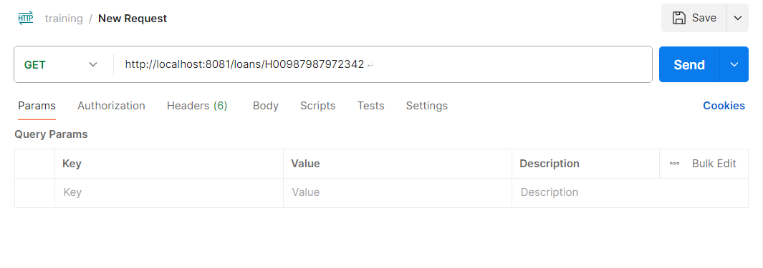

***STEP 5:***

***OUTPUT,***

